THE SEMANTIC WORKBENCH: Technical Research & Brief
Subject: Spatial Computing Interfaces for Knowledge Synthesis
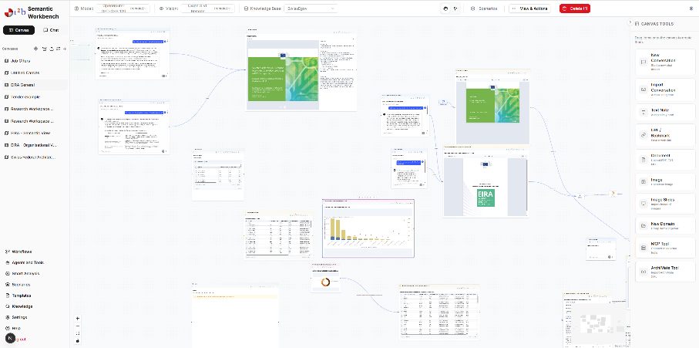
1. Executive Summary & Research Objectives
Current AI interfaces rely on chronological streams which fail to capture the multi-dimensional relationships of complex knowledge work. SemanticCanvas utilizes an infinite spatial coordinate system to anchor information, using proximity as a semantic signal.
The primary research objective is to leverage human spatial reasoning to manage high-density, multi-modal datasets through a persistent infinite canvas.
2. Core UI & Spatial Logic
Infinite Spatial Field
Unlike document-based or list-based UIs, the Workbench utilizes an infinite canvas managed by a customized React Flow implementation. This provides a "World-Space" where data positioning serves as a cognitive anchor for the user's memory.
Semantic Zoom & Level of Detail (LOD)
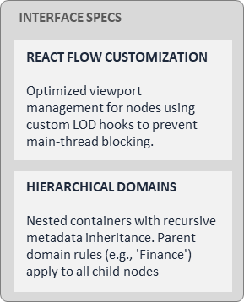
To manage cognitive load and rendering performance, the system implements a recursive LOD system
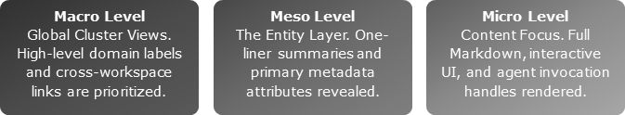
Hierarchical Domains
Domains are contextual containers that define the environment's physics and logic:
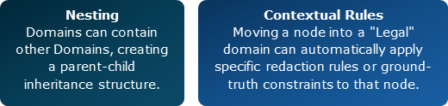
3. Knowledge Management: The "Thing" & Ingestion
Dynamic & Polymorphic "Things"
A "Thing" is the atomic unit of the environment. It is dynamic and undergoes state changes:
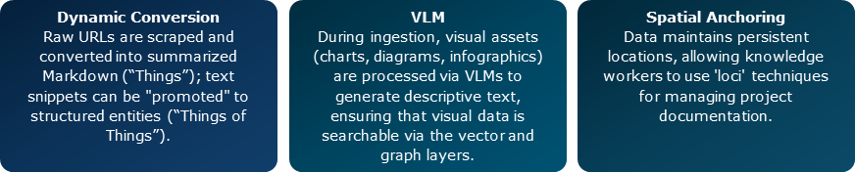
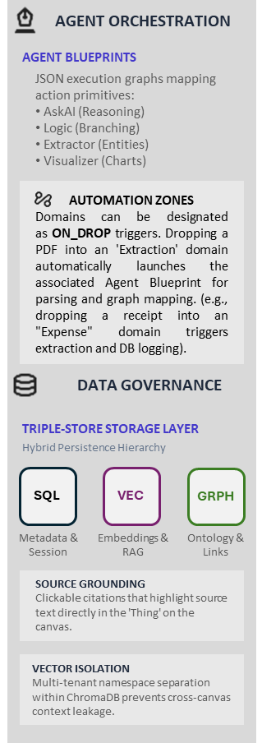
Knowledge Base Ingestion & RAG
- Retrieval-Augmented Generation (RAG): the system supports PDF, Word, Excel, and structured web data.
- Source Transparency: Every agent response includes deep-links to the specific "Thing" on the canvas, with highlighted text segments for verification.
4. Advanced Intelligence & Automation
Smart Analysis
One-click structured analysis based on the Domain context: PESTEL/SWOT/GAP, As-Is vs. To-Be, etc.
Iterative Smart Templates (The Audit Loop)
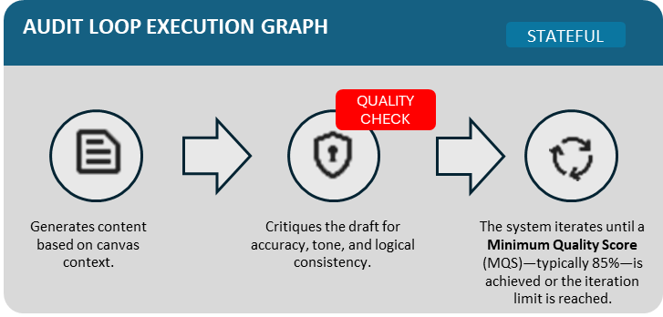
To ensure high-fidelity output, the Workbench moves beyond single-shot prompting. High-fidelity documents are created via an Iterative Audit Loop.

5. Ontology & The Semantic Graph Architecture
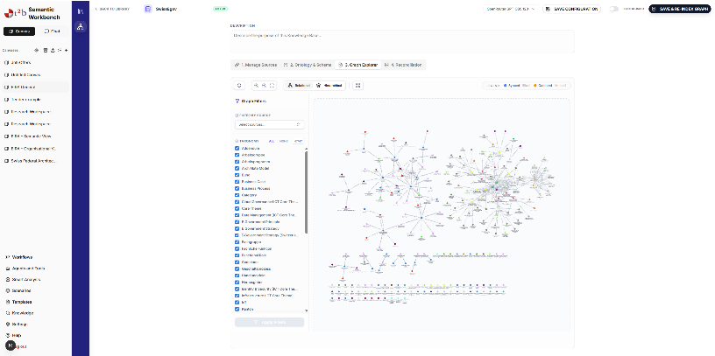
Beyond Vector Search
Similarity (Vector RAG) is insufficient for complex reasoning. The Workbench adds an Ontology Layer using ArcadeDB. This graph-first approach allows agents to understand explicit relationships that standard similarity searches miss.

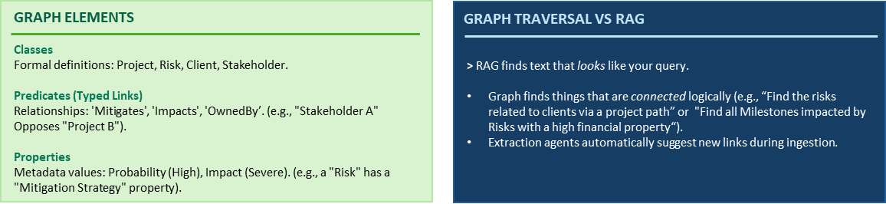
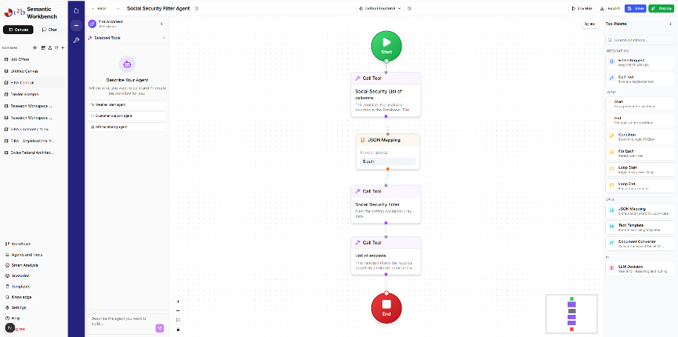
6. Model Context Protocol (MCP) & Tools
The environment is extensible via MCP v1.0:
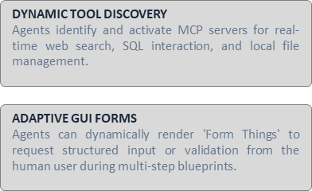

7. Admin, Security & Maintenance
Security Protocols
- RBAC: Role-Based Access Control (Admin, Editor, Viewer).
- Vector Isolation: Per-canvas namespace separation to prevent cross-project data leakage.
- PII Redaction: Real-time filtering to ensure sensitive data is not dispatched to external LLM providers.
System Health
- Database Vacuums: Scheduled maintenance for SQLite and ArcadeDB integrity.

- Monitoring: Real-time tracking of token usage, vector status, and disk overhead for graph indices.

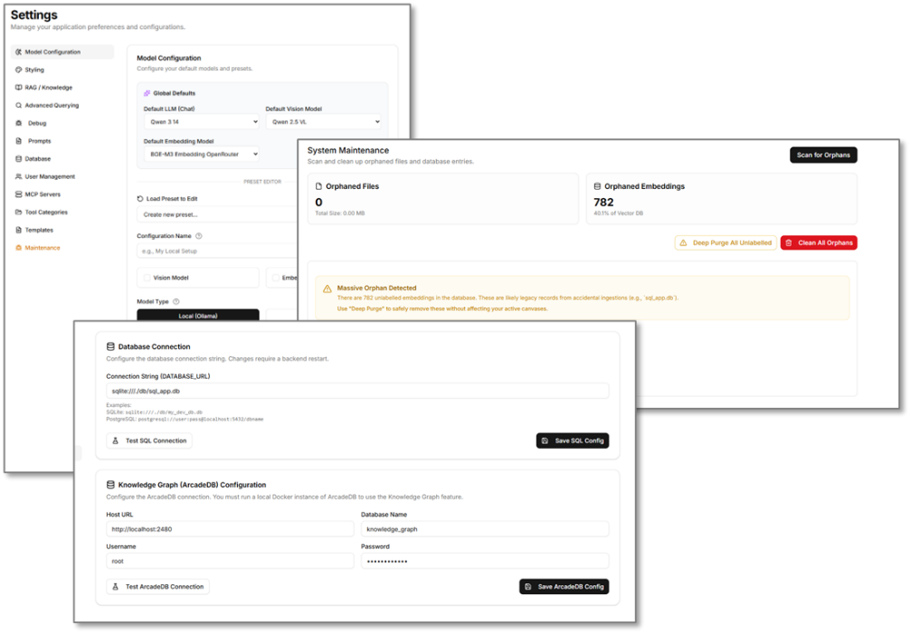

Find more information about AI for Business at: 🌐 www.t2b.ch

